Note: This document is “view only”. Please create a copy of this document and save it to your drive.

**SOP- Team Member Onboarding - Systems Vault**

**PREREQUISITES**

[SOP MASTER - Team Member Onboarding & Offboarding - Systems Vault](https://docs.google.com/document/d/1HqV60Qly2Z54F19tthCtv7EV7rQrT-ziHlrEgWp2q3c/edit?usp=sharing)

[Teamwork PM](http://sarahnoked.com/teamwork)

1. SARAHNOKED.COM

Lastpass

Zoom

[Ontraport](http://sarahnoked.com/ontraport)

Teamwork Chat

[Signnow](https://app.signnow.com/webapp/) (digital contracts)

Google Admin Console

[Master: Team Member Details - Systems Vault](https://docs.google.com/spreadsheets/d/18Z8RMlT9UFzxmhKZOqucHuIaKXHb4hNYR_VU0e2RLxE/edit?usp=sharing)

[SOP MASTER - Team Member Training & Ongoing - Systems Vault](https://docs.google.com/document/d/1zz841Og7cOQZMyhL-JRnpZ3l8dWQGueBpKqMS67ldYM/edit?usp=sharing)

[Template- Welcome to the Team! - Systems Vault](https://docs.google.com/document/d/15Lm-dPyRlXNcWvq_uPB61gWzgA1pmOWJ45_XmXsnqJg/edit?usp=sharing)

[SOP- Password Sharing- Systems Vault](https://docs.google.com/document/d/1tEfj5QxLYcticR1H0C5vVt6V7qugElYMgfhypYgCucc/edit?usp=sharing)

[SOP- Task Management- Systems Vault](https://docs.google.com/document/u/0/d/1oGhOzbOIGKAnS-01sNyhcUzXfYbaUlWYjGva2rL6fxQ/edit)

Independent Contractors Agreement

‘Sarah Noked Team Shared Calendar’ Calendar, accessible from your @sarahnoked.com email address

**PURPOSE**

To ensure new team members & independent contractors are onboarded swiftly and warmly.

**POLICY**

This process should take place every time a new team member or independent contractor is approved for onboarding.

A task list template is set up in [Teamwork PM](http://sarahnoked.com/teamwork) under SN Operations (and as indicated in Step 1 of the Process), which includes all the tasks to swiftly and efficiently onboard team members

**PARTY**

Online Business Manager

**PROPERTY**

Online Business Manager

**PROCESS**

Part 1: Implement the “Staff Member Onboarding” Task template in [Teamwork PM](http://sarahnoked.com/teamwork)

Part 2: Send employment agreement via [Signnow](https://app.signnow.com/webapp/) & back up the signed copy

Part 3: Set up @sarahnoked.com email address

Part 4: Create a user for the new team team member in the [Teamwork PM](http://sarahnoked.com/teamwork) account

Part 5: Back up new team members details in all relevant master docs & team calendar (address, contact deets, birthday)

Part 6: Share SN Google Calendars

Part 7: Set up Teamwork Chat access & assign relevant channels

Part 8: Create a basic [Zoom](https://us02web.zoom.us/account/user#/) account with the new team member’s @sarahnoked.com email address

Part 9: Send [Template- Welcome to the Team! - Systems Vault](https://docs.google.com/document/d/15Lm-dPyRlXNcWvq_uPB61gWzgA1pmOWJ45_XmXsnqJg/edit?usp=sharing)  to the new team member

Part 10: Request & backup bank account & direct transfer details  
Part 11: Tag the new team member with the tag “Newsletter All” in Ontraport

Part 12: Duplicate all team-wide recurring tasks and assign to the new team member (skip this if they are a contractor, they have their own recurring task template)

Part 13: Add the contractor recurring task list if they are an OBM contractor

Part 14: Setup relevant gmail filters (assign to Sarah)

Part 15: Share [Lastpass](https://lastpass.com/) passwords

Part 16: Team Training

Part 17: Add Team Member to Relevant Google Drive Folders

**PROCEDURE**

**Part 1: Implement the “Staff Member Onboarding” Task template in** [Teamwork PM](http://sarahnoked.com/teamwork)

1. From the [Teamwork PM](http://sarahnoked.com/teamwork) dashboard, click “Projects” in the top menu and navigate to the “Sarah Noked OPERATIONS” project
2. Click “Add New Task List” > Advanced > select the “Staff Member Onboarding” task template

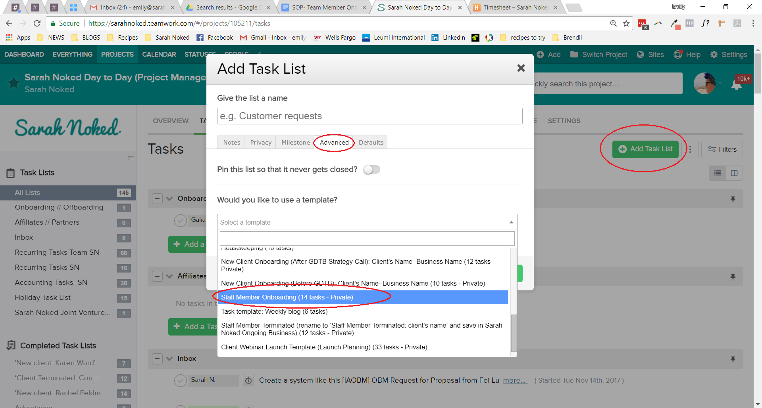

1. Update the title of the task list to “Staff Member Onboarding: New Staff Member Name”

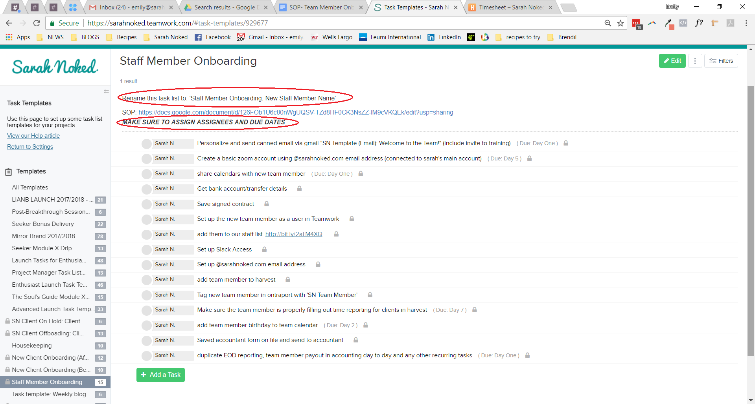

1. Update assignees and due dates depending on which current team members are assisting in the onboarding and the exact date the new team member is being onboarded to the business.

**Part 2: Send employment/contractor agreement & contract & back up the signed copy**

1. Edit SN Contract: Independent Contractor Agreement with hourly rate/ project rate and upload to [Signnow](https://app.signnow.com/webapp/)
2. Set a task in Teamwork to follow up with candidate after 3 days
3. When signed save the contract to Sarah Noked hard drive (Sarah does this)

**Part 3: Set up @sarahnoked.com email address**

1. Login to the [sarah@sarahnoked.com](mailto:sarah@sarahnoked.com) gmail account, open a new tab, and navigate to [Google Admin Console](http://admin.google.com/)
2. Select “Users”

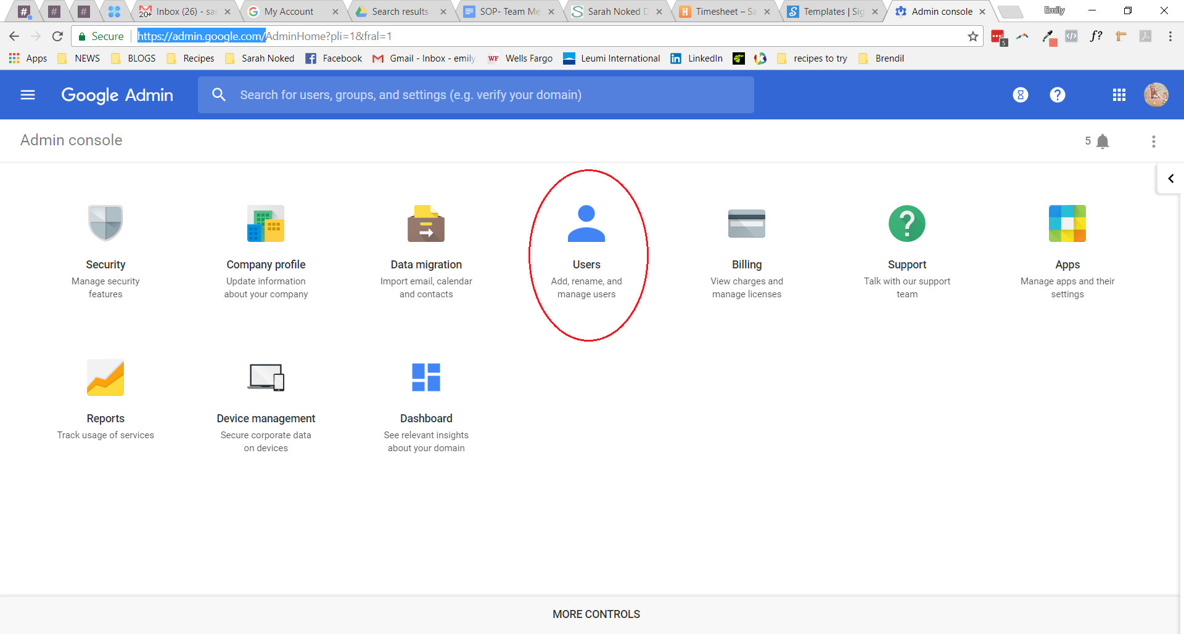

1. In the bottom right corner, select “Add New User”
2. Input the new team member details and set a temporary password which they will reset after their first login.

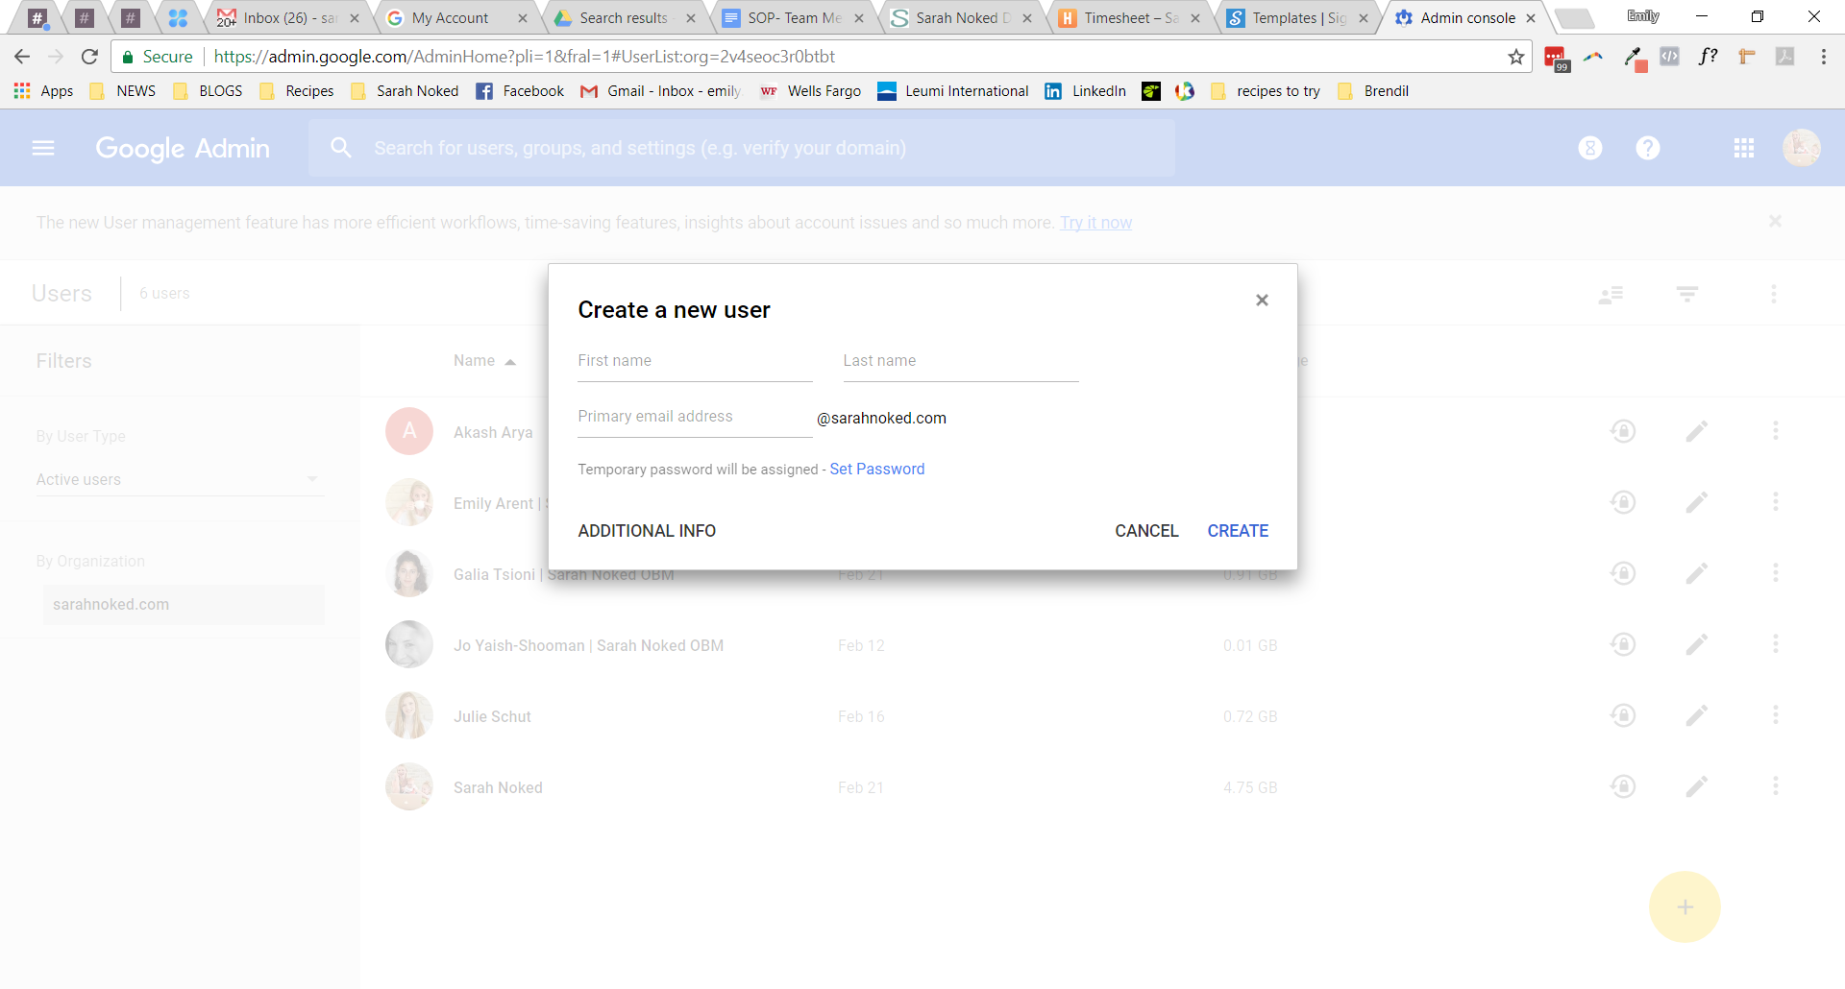

1. Send an email to the new team member’s personal email address to notify them that their account is set up & pass along their temporary password using [SN Template (Email): New Team Member Biz Email Address - Systems Vault](https://docs.google.com/document/u/0/d/17QqsXRUFKsPbgxSeRbtnD9CfAeLDCZY8K-RwRyQNKDM/edit)

**Part 4: Create a user for the new team member in the** [Teamwork PM](https://sarahnoked.teamwork.com/)

1. From the [Teamwork PM](http://sarahnoked.com/teamwork), navigate to “People” in the top menu
2. Select “Invite Users” and add in the new team member’s details + @sarahnoked.com email address

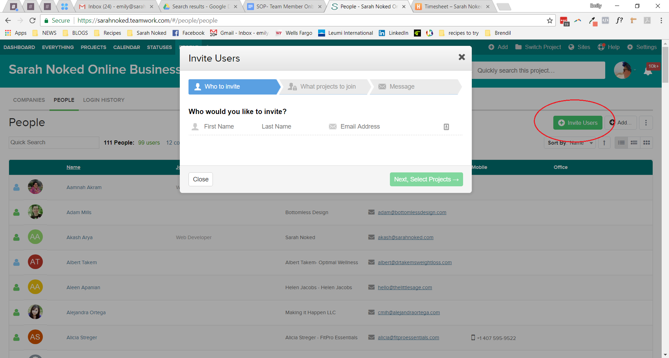

1. A submenu will drop down in which you must assign the new team member to a business (Sarah Noked) and define their user type (standard user)
2. Click “Next, Select Projects” and:
   1. Add the new team member to the relevant Sarah Noked Projects
      1. If the new team member will also be collaborating on client projects biz-wide, add them to all client projects
      2. If the new team member will be collaborating on select client projects, add them to only those client projects.
      3. If the new team member will only be working on internal SN client projects, do not give them access to any client projects
      4. If the new person is an OBM contractor add them to the Contractors project
   2. Select user permissions
      1. In general, user permissions during the first three months are set as “Default” with no ability to add users or projects.
         1. Note that you should go through this and use your judgement, VAs, for example, need access to all future projects
      2. If the new team member is taking on clients immediately or is filling a higher-level management role in the business, give them permission to add users and create projects from day 1.

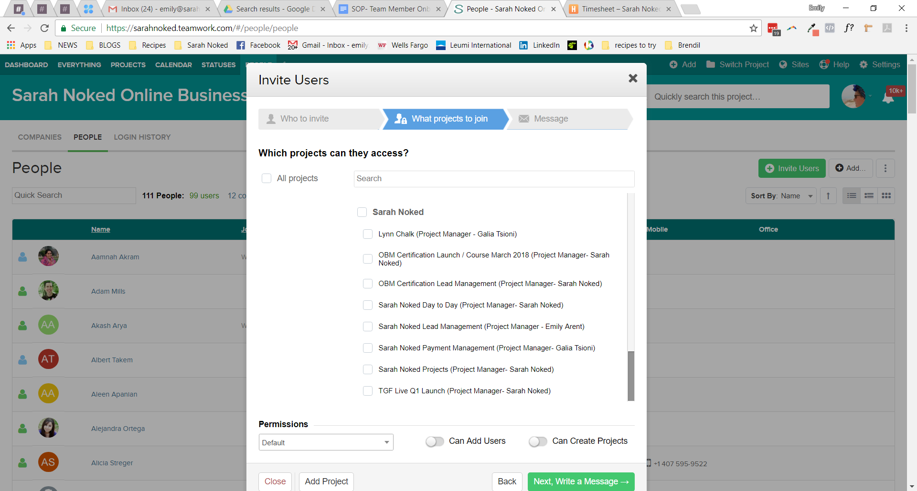

1. Click “Next, Write a message”
2. Modify the internal SN TW Onboarding message 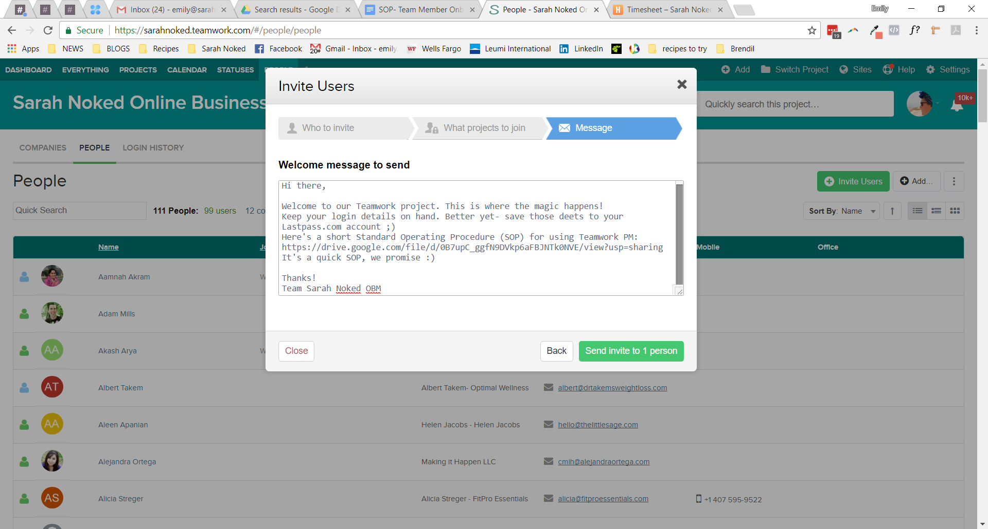
3. Click “Send Invite to 1 person”
4. Update user to set to the correct Time Zone and week start day:

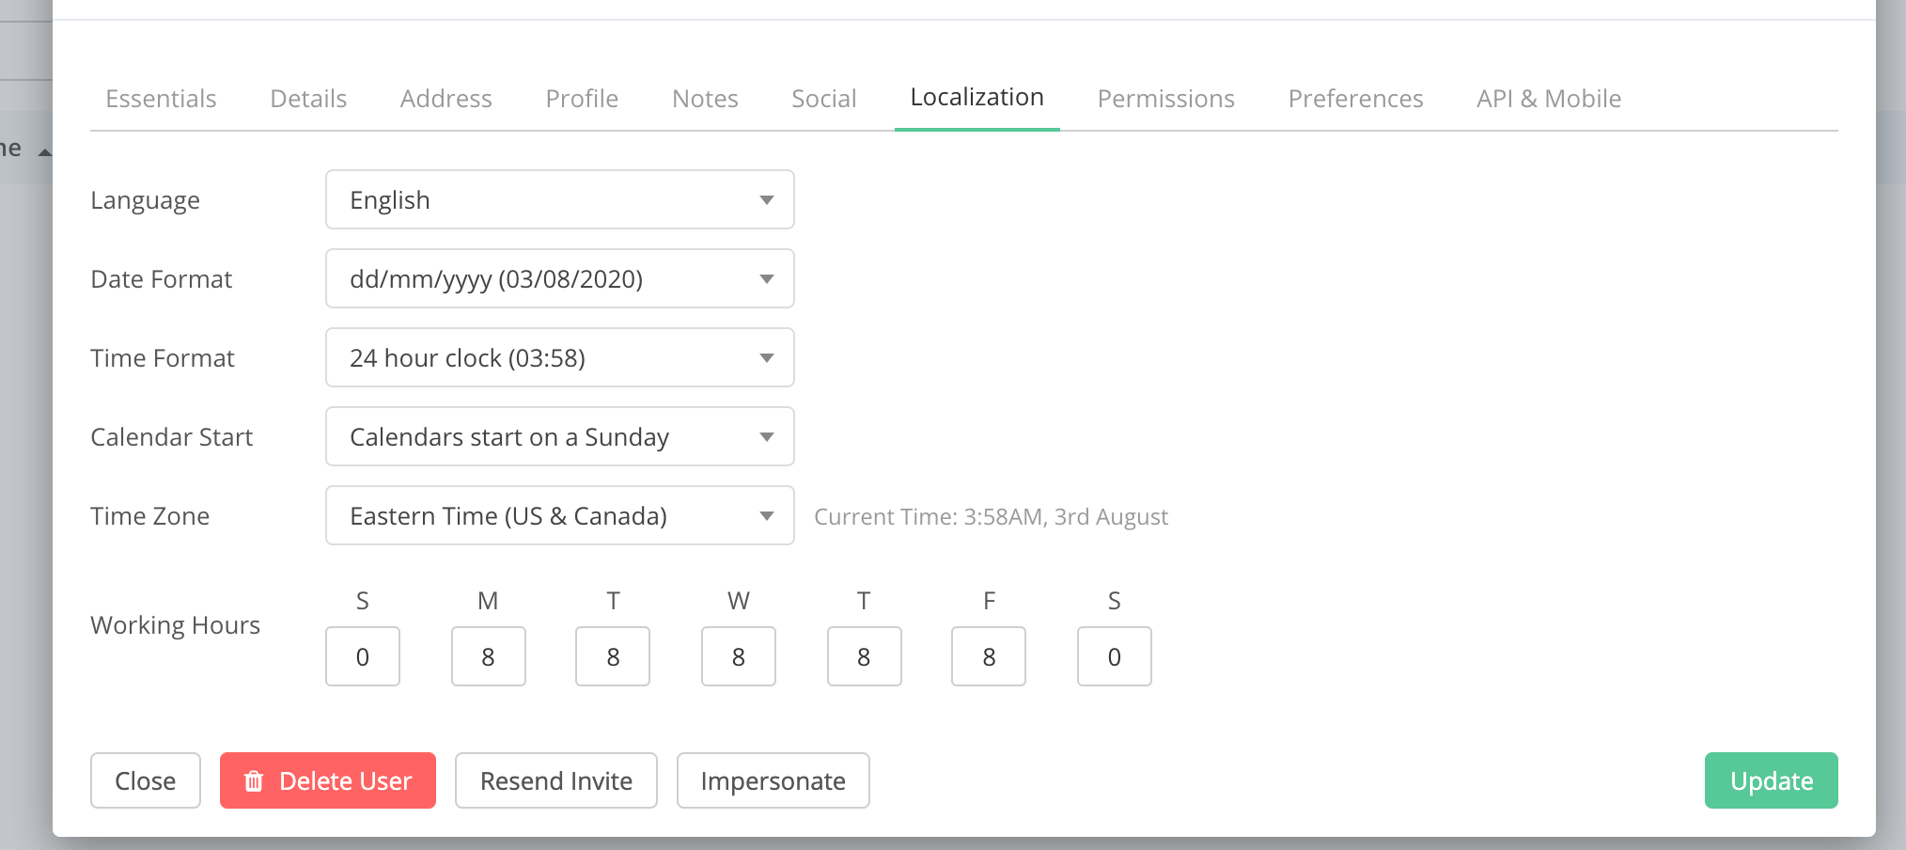

**Part 5: Back up new team members details in all relevant master docs & team calendar (address, contact deets, birthday)**

1. Add team member’s name and contact details to [Master: Team Member Details - Systems Vault](https://docs.google.com/spreadsheets/u/0/d/18Z8RMlT9UFzxmhKZOqucHuIaKXHb4hNYR_VU0e2RLxE/edit)
2. Add team member’s b-day to the SN Team Google Calendar as a recurring annual event.

**Part 6: Share SN Google Calendars**

1. Share SN Google Calendars with the new team member via their @sarahnoked.com email address.
   1. If they will be working with other team members - share individual team member’s biz calendars
   2. Everyone - SN Team Calendar
   3. Internal team members - Sarah Noked Promotional Calendar
   4. To update their birthday, create a contact for them and add their birthday

**Part 7: Set up Teamwork Chat access & assign relevant channels**

1. Log in to [Teamwork Chat](https://sarahnoked.teamwork.com/chat/channels/43094)
2. Navigate to Users and invite the new user

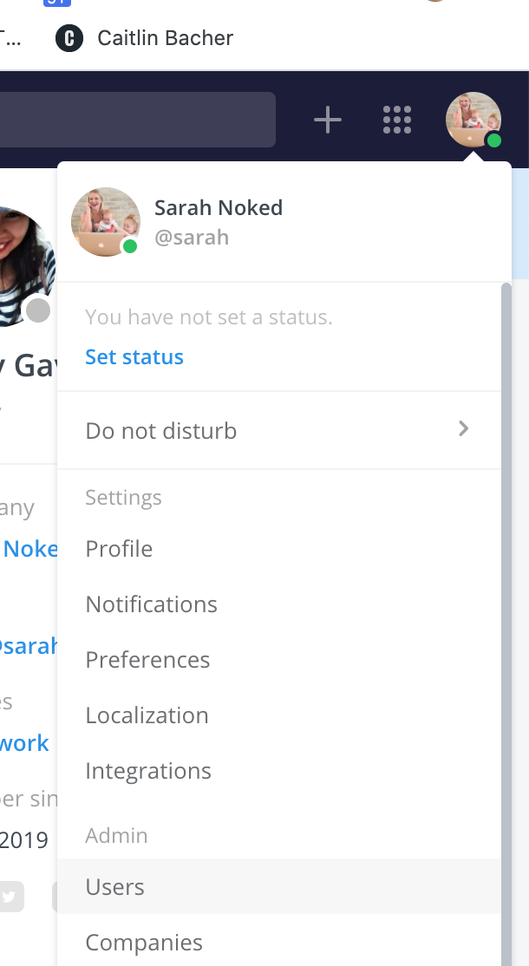

1. Find the channel you’d like to add the team member to
2. Navigate to 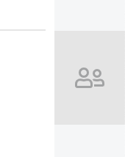 on the right side and press “+ Add Member”
3. Repeat this for every channel you would like to add the new user to

**Part 8: Create a basic** [Zoom](https://us02web.zoom.us/account/user#/) **account with the new team member’s @sarahnoked.com email address**

1. Log-in to [Zoom](https://us02web.zoom.us/account/user#/) > Users > Add User

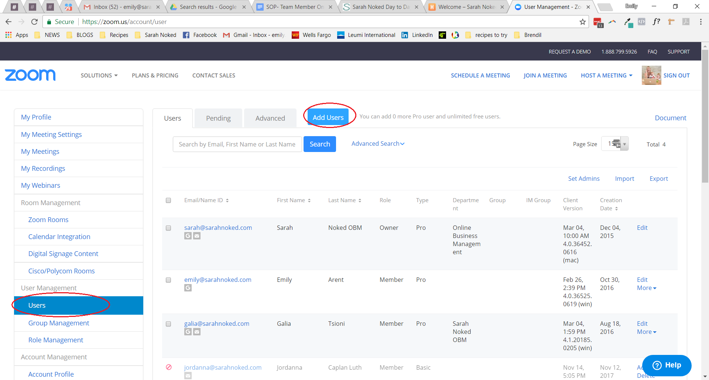

1. Set up a BASIC account type using their @sarahnoked.com email address.

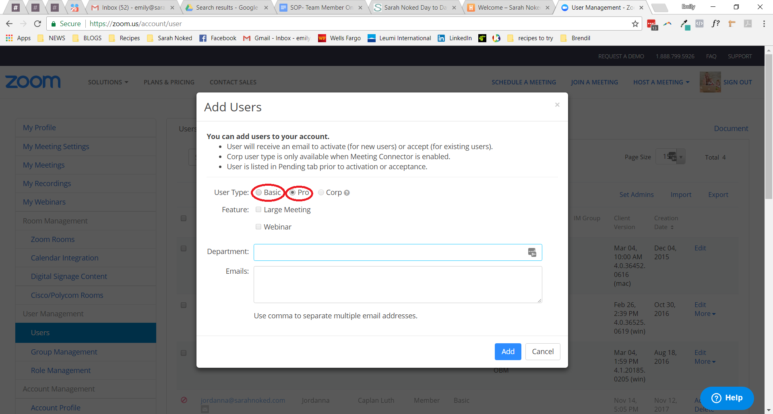

**Part 9: Send** [Template- Welcome to the Team! - Systems Vault](https://docs.google.com/document/d/15Lm-dPyRlXNcWvq_uPB61gWzgA1pmOWJ45_XmXsnqJg/edit?usp=sharing)   **email to the new team member**

1. Welcome email [Template- Welcome to the Team! - Systems Vault](https://docs.google.com/document/d/15Lm-dPyRlXNcWvq_uPB61gWzgA1pmOWJ45_XmXsnqJg/edit?usp=sharing)  is sent by Sarah to the new team member’s @sarahnoked.com email address informing them that they’ve been onboarded to all tech and THUNDERCATS ARE GOOOOOO.

**Part 10: Backup bank account & direct transfer details**

1. Save bank account / Paypal details for making payment transfers

**Part 11: Tag the new team member with the tag “Newsletter All” in Ontraport**

1. Login to Ontraport > Contacts
2. The team member should already be in our system (if they opted-in for a freebie during their interview process) but occasionally an independent contract will not yet be in the system.
   1. Select “Add Contact” > Input Full Name & Email > scroll to the “tags” section and add “SN Newsletter” tag

**Part 12: Duplicate all team-wide recurring tasks and assign to the new team member (skip this if they are a contractor, they have their own recurring task template)**

1. Login to Teamwork > Projects > SN OPERATIONS
2. Create recurring daily tasks (Sunday-Thursday) for the new team member
   1. Send Sarah BOD Report
   2. Send Sarah EOD Report
3. Create recurring monthly tasks (end of each month) for the new team member
   1. Report monthly travel expenses // sick days
   2. Check their @sarahnoked.com Spam folder
   3. Notify Sarah of OOO days for the upcoming month

**Part 13: Add the contractor recurring task list if they are an OBM contractor**

1. Access the project ‘Sarah Noked CONTRACTORS (Project Manager- Sarah)’ and add the task template ‘{Contractor Full Name}: Contractor Recurring Tasks’
   1. Update the person responsible, due dates, and name of the task list
   2. Use [SOP- Task Management- Systems Vault](https://docs.google.com/document/u/0/d/1oGhOzbOIGKAnS-01sNyhcUzXfYbaUlWYjGva2rL6fxQ/edit)

**Part 14: Setup relevant gmail filters (Sarah does this)**

**Part 15: Share Lastpass passwords**

See: [SOP- Password Sharing- Systems Vault](https://docs.google.com/document/d/1tEfj5QxLYcticR1H0C5vVt6V7qugElYMgfhypYgCucc/edit?usp=sharing)

**Part 16: Team Training**

1. Assign to team member to review the relevant SOPs and to sign off here [Master: Team Training - Systems Vault](https://docs.google.com/spreadsheets/u/0/d/1rSRJUxVPAJILARhRd2hkTxN1xBhpdGTTdBfwxL3RT04/edit)
2. Set up a meeting with them to go through [SOP MASTER - Team Member Onboarding & Offboarding - Systems Vault](https://docs.google.com/document/d/1HqV60Qly2Z54F19tthCtv7EV7rQrT-ziHlrEgWp2q3c/edit?usp=sharing)

**Part 17: Add Team Member to Relevant Google Drive Folders**

**Created by:**

**Department:** Growth

**Date:**

**Revised:**

**Revised by:**